ASSIGNMENT QUESTIONS

Point values are in [brackets].

1. How many rows are in the Sales query? [1] **53**

2. How many columns are in the Sales query? [1] **18**

3. On Sheet1 of your workbook, create a pivot table that shows the total Orders by Year by

Region. Your pivot table should have the following characteristics [2]

* Show Region in row, Year in column
* Rename your value field to Total Orders
* Remove field headers
* Rename your pivot table to Orders

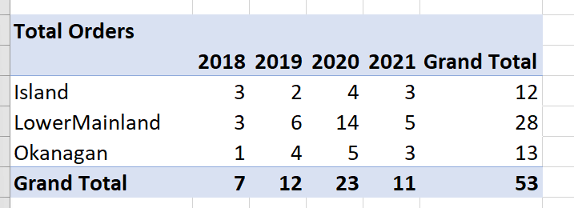

4. Referencing this pivot table, how many orders happened in the LowerMainland in   
2020? [1] **14**

5. Continuing in Sheet1 of your workbook, create a pivot table that shows Average, Maximum,

and Minimum Payment Days by Sales Channel. Your pivot table should have the following

characteristics [2]

* Sales Channel as row
* Three columns (Avg Days, Max Days, Min Days)
* Values formatted to zero decimal places
* Remove field headers

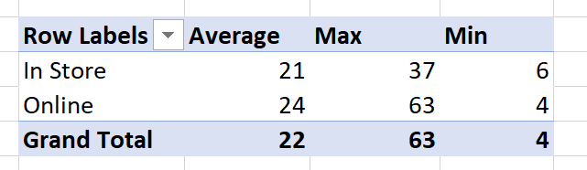

6. Which Sales Channel had the smallest number of Payment Days? [1] **Online**

7. Continuing in Sheet1 of your workbook, create a pivot table that shows the Total Sales by

Region and City . Your pivot table should have the following characteristics [3]

* Region, then City, as row
* Value formatted as currency with zero decimal places
* Show subtotals at top of group
* Apply conditional formatting to all cells showing Sum of Total Sales values by City > highlight the highest Total Sales value with (Green Fill & Dark Green Text)
* Remove field headers
* Remove +/- buttons

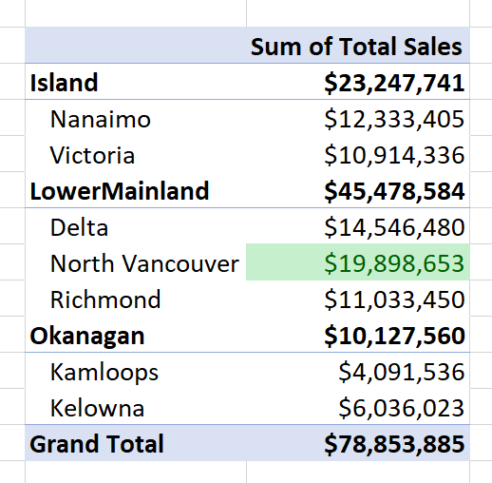

8. Which Region contains the City with the highest Total Sales? [1] **LowerMainland**

9. Continuing in Sheet1 of your workbook, create a pivot table that shows Total Profit for the

Island by Year and Sales Channel. Your pivot table should have the following

characteristics [2]

* Filter on Region
* Year as row, Sales Channel as column
* Show values as a percent of Grand Total
* Format values to one decimal place

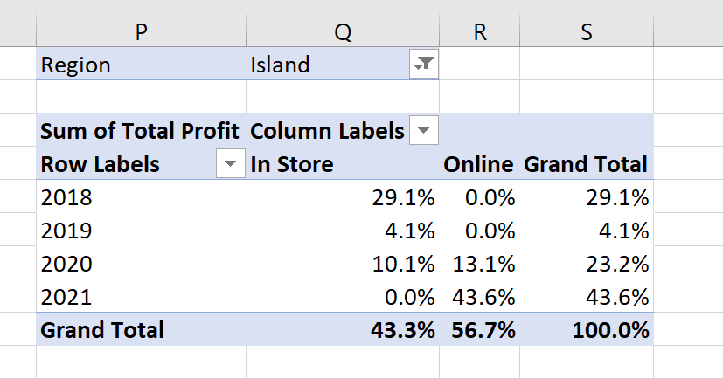

10. What percent of profit comes from Online sales? [1]

**56.7%**

11. Continuing in Sheet1 of your workbook, create a pivot table that shows the Sum of Units

Sold by Item Type. Your pivot table should have the following characteristics [2]

* Rename the value field to Qty
* Sort the values in descending order
* Remove field headers
* Apply conditional formatting to all cells showing Qty values by Item Type > use green Data Bars

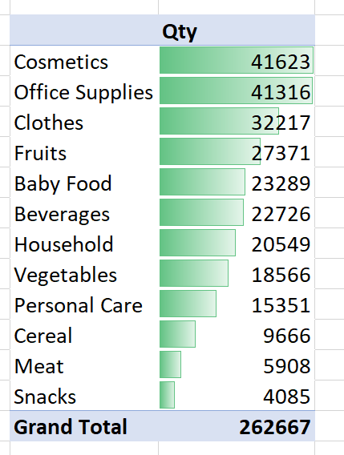

12. What is the quantity of Fruits sold? [1] **27371**